  - NYSJ & NEXSOLVEAI MAGAZINE | EDUCATIONAL SAMPLE

Illustrative Single-Channel Absorbance Data and a Proposed Dual-Wavelength Validation Framework
Muhammad Saleh¹ · Muhammad Rehan¹ · Muhammad Talha¹ · Muhammad Musa¹ · Dr. Muhammad Hassan Sayyad²*
¹ Illustrative affiliation: “NexSolveAI Online High School, Lahore, Pakistan” (fictional; not an existing or accredited school).
² NexSolveAI Institute of Engineering Sciences and Technology, Lahore, Pakistan (fictional; not an existing or accredited Institute).
* Mentor and corresponding author: Dr. Muhammad Hassan Sayyad | info@nexsolveai.net
EDUCATIONAL SAMPLE — constructed synthetic values; no physical experiment, paired-wavelength test, or peer review. Names and contribution statements require approval before public distribution.

Abstract
Background: Particle scattering may complicate absorbance-based concentration estimates in turbid samples. Objective: To demonstrate transparent reporting of constructed single-channel calibration data and formulate a testable two-wavelength protocol. Methods: Six concentrations (0–10 mg/L) were assigned deterministic absorbance values under two illustrative optical conditions, using Aclear = 0.070 + 0.061c and Aturbid = 0.080 + 0.047c. These are constructed numerical relationships, not a physically parameterized scattering simulation. A prospective paired-wavelength comparison is specified but not executed. Results: The constructed slopes are 0.061 and 0.047 absorbance units per mg/L. The lines intersect at approximately 0.714 mg/L. No independent test errors or uncertainty estimates are available. Conclusions: The example demonstrates how calibration trends and untested hypotheses should be reported; it cannot establish a benefit from dual-wavelength estimation.
Keywords: educational sample; constructed data; optical absorbance; turbidity; dual wavelength; calibration; research reporting

1. Introduction
The Beer–Lambert relationship links decadic absorbance to the concentration of an absorbing species under appropriate optical assumptions [1]. Suspended particles can scatter light, altering measured transmission and potentially changing apparent absorbance according to sample and detector geometry [4,5]. This makes calibration transfer between clear and turbid samples a meaningful scientific question.
Dual-wavelength spectrophotometry has been analyzed theoretically for turbid samples [2], and reference-wavelength selection is a key design decision [3]. More detailed treatments consider wavelength-dependent scattering and optical path length [4], while detector collection of scattered light can also change the apparent signal [5]. These approaches cannot be treated as interchangeable: subtraction requires a suitable reference channel, regression requires paired data and validation, and a physically based scattering model requires optical parameters.
This article is a teaching example rather than a completed test of any correction method. It demonstrates a transparent constructed dataset, identifies the limits of inference, and states a future research protocol suitable for student investigation.

1.1 Research question and hypothesis
Future research question: When dye concentration and turbidity vary independently, does a paired two-wavelength estimator yield lower held-out concentration error than a one-wavelength baseline? Hypothesis (untested): A carefully selected reference wavelength may improve predictions when its response to dye absorption differs from its response to scattering. Null hypothesis: The paired model offers no reduction in expected held-out error. No present data test either hypothesis.

1.2 Scope and contribution
The present contribution is limited to reproducible arithmetic for six constructed concentration points, a transparent distinction between completed and proposed work, and a predeclared prospective validation plan. It is not a new optical method, a validated sensor, or a reproducible physical scattering simulation.

2. Materials and Methods

2.1 Completed construction of the illustrative dataset
The independent variable is dye concentration c in mg/L, with c = 0, 2, 4, 6, 8, and 10. Two dimensionless decadic absorbance series were constructed using the exact deterministic expressions below. No dye, wavelength, turbidity units, optical path length, instrument, noise distribution, or random seed was specified. “Clear” and “turbid” are illustrative labels only; the coefficients are not inferred from a physical scattering model.
A_{clear} = 0.070 + 0.061c | (1)
A_{turbid} = 0.080 + 0.047c | (2)
The coefficients 0.061 and 0.047 have units L mg⁻¹ when c is expressed in mg/L; the intercepts and absorbances are dimensionless. These equations exactly reproduce the table, but they are not experimentally calibrated.

2.2 Conceptual physical model (not implemented)
A prospective model for decadic absorbance at wavelength λ may be written as Equation (3), where ε is the effective decadic absorption coefficient (L mg⁻¹ cm⁻¹), L is optical path length (cm), S is an approximate dimensionless scattering contribution, τ is a defined turbidity descriptor, and η is a dimensionless noise term. Additivity of S is a simplifying assumption and may fail under multiple scattering or geometry-dependent light collection [4,5].
A(λ) = ε(λ)cL + S(λ, τ) + η(λ) | (3)
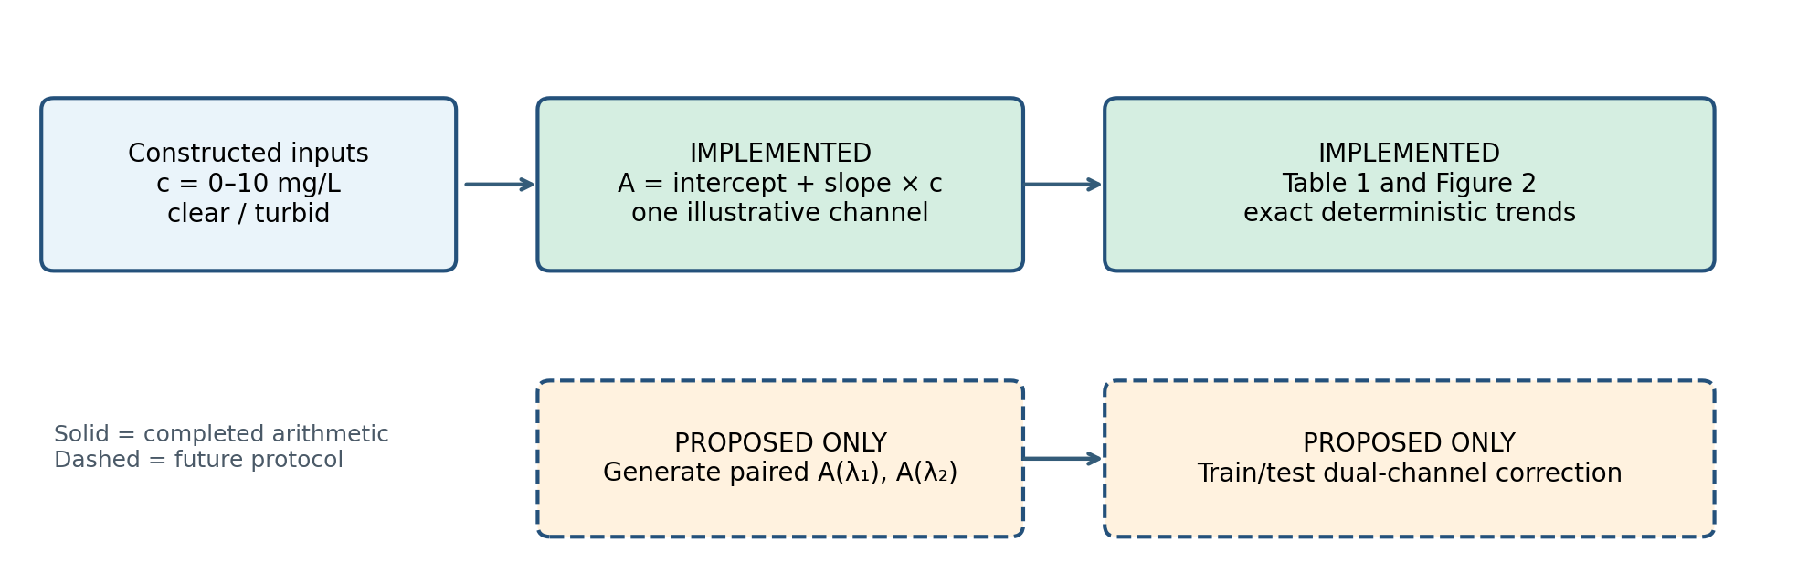
Figure 1. Actual constructed single-channel arithmetic (solid boxes) versus a proposed paired-wavelength simulation and validation (dashed boxes). The latter was not executed.

2.3 Tabulated constructed values
Concentration (mg/L) | Illustrative clear A | Illustrative turbid A
0 | 0.070 | 0.080
2 | 0.192 | 0.174
4 | 0.314 | 0.268
6 | 0.436 | 0.362
8 | 0.558 | 0.456
10 | 0.680 | 0.550
Table 1. Constructed, dimensionless absorbances. Each value follows Equations (1) and (2); these are not measured observations.

2.4 Prospective two-wavelength study protocol (not performed)
Select a dye with a measured absorption spectrum. Choose λ₁ near a dye-sensitive absorption band and λ₂ where dye absorption is lower but background scattering remains measurable; confirm this experimentally or in a documented optical model. Prespecify wavelength choices before testing. For each independently varied concentration–turbidity condition, generate or measure paired A(λ₁) and A(λ₂), along with dye-free turbidity blanks and clear-water calibration controls. Record sample path length, geometry, detector response, and optical parameters.
Fit a one-channel baseline and a paired-channel regression on training conditions only. Hold out entire concentration–turbidity combinations, not merely replicate readings from conditions also used in training. Choose wavelength pairs, preprocessing, and model complexity within training/validation folds. Compare predictions on the same held-out samples; include a clear-calibration-to-turbid-transfer baseline. Repeat simulations across prespecified detector-noise, baseline-drift, wavelength-mismatch, and turbidity scenarios; distinguish numerical Monte Carlo variability from physical instrument repeatability.
ĉ₁ = a₀ + a₁A(λ₁) | (4)
ĉ₂ = b₀ + b₁A(λ₁) + b₂A(λ₂) | (5)
MAE = (1/N) Σ_{i} |ĉ_{i} − c_{i}| | (6)
Here ĉ₁ and ĉ₂ are estimated concentrations from one- and two-channel models; aⱼ and bⱼ are fitted coefficients; N is the number of independent held-out predictions; and i indexes held-out samples. Primary outcome: held-out mean absolute error (MAE, mg/L); secondary outcomes: signed bias, root-mean-square error, and performance by turbidity. Report uncertainty intervals from independent simulation repetitions. None of these outcomes is available for the current six-row example.

3. Results
The constructed clear and turbid lines have slopes of 0.061 and 0.047 absorbance units per mg/L, respectively, and intercepts 0.070 and 0.080. Equating the two expressions gives c = (0.080 − 0.070)/(0.061 − 0.047) ≈ 0.714 mg/L, explaining their low-concentration intersection. At 10 mg/L, the constructed absorbances are 0.680 and 0.550. The difference in slopes is an assigned property of the numerical example; it does not demonstrate scattering physics.
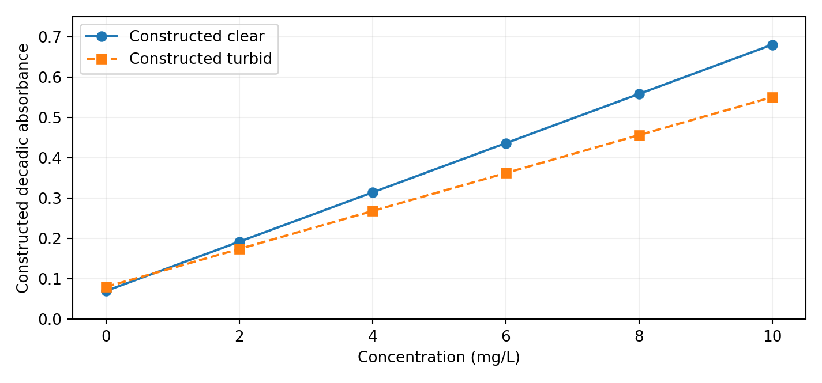
Figure 2. Exact deterministic lines generated by Equations (1) and (2), not experimental observations or independent wavelength channels.
No paired second-wavelength data exist. Consequently, no two-wavelength coefficients, held-out MAE, statistical significance, detection limit, or accuracy improvement can be estimated from Table 1.

4. Discussion
The different assigned slopes illustrate how calibration lines can vary across labeled optical conditions, but their physical origin is not identifiable from the construction. Literature on scattering and multi-wavelength measurements provides a motivation for further study [2–5], not confirmation of the untested correction. A defensible evaluation must compare one- and two-channel predictions on identical held-out samples while controlling for dye-free scattering backgrounds and wavelength selection.

4.1 Applications and potential impacts
Educational impact is immediate: students can learn model specification, dimensional analysis, data provenance, falsifiable hypotheses, and appropriate reporting of negative or unavailable results. Environmental screening and commercial process monitoring are potential future applications only after physically grounded simulations, calibration transfer tests, independent measurements, uncertainty assessment, and application-specific performance thresholds. Public-policy or quality-of-life claims would additionally require field validation and appropriate regulatory evaluation. This example does not establish such outcomes.

4.2 Limitations
The dataset is constructed, noiseless, and single-channel; clear/turbid labels lack physical turbidity units. Dye identity, wavelength, scattering parameters, detector geometry, and experimental controls are absent. The proposed second channel and calibration comparison were not implemented. The work therefore supports arithmetic demonstrations and a future protocol, not sensor validation, detection limits, or physical claims about scattering.

5. Conclusions
Six constructed absorbance values per labeled optical condition illustrate different linear calibration trends. The associated dual-wavelength hypothesis is explicitly untested. A genuine research study would require documented optical inputs, paired measurements, relevant blanks, independent held-out conditions, and uncertainty-aware comparisons before concluding that a two-wavelength estimator improves accuracy.

Declarations and educational-use notice
Status: Educational sample; not peer reviewed or presented as completed original experimental research. Affiliation: “NexSolveAI Online High School” is fictional and does not represent an existing or accredited school. The second affiliation and the names and contributions of all listed individuals require confirmation before public release. Data availability: All constructed values and exact generation formulas appear in this document; no source code or physical simulation exists for these data. AI assistance: AI tools assisted in drafting and formatting; named contributors must verify and approve the content. Funding, competing interests, and individual author contributions: not verified; these must be completed truthfully before any submission under named authors. Ethics: No human or animal participants are described.

References
[1] Harris, D. C., & Lucy, C. A. (2020). Quantitative Chemical Analysis (10th ed.). Macmillan Learning.
[2] Cowles, J. C. (1965). Theory of dual-wavelength spectrophotometry for turbid samples. Journal of the Optical Society of America, 55(6), 690–692. https://doi.org/10.1364/JOSA.55.000690
[3] Stewart, J. E. (1973). Optimum reference wavelength selection in multi-wavelength spectrophotometry of turbid media. Applied Spectroscopy, 27(4), 287–288.
[4] Zhang, H., Tsuchiya, Y., Urakami, T., Miwa, M., & Yamashita, Y. (1998). Time integrated spectroscopy of turbid media based on the microscopic Beer–Lambert law: Consideration of the wavelength dependence of scattering properties. Optics Communications, 153(4–6), 314–322. https://doi.org/10.1016/S0030-4018(98)00267-3
[5] Wind, L., & Szymanski, W. W. (2002). Quantification of scattering corrections to the Beer–Lambert law for transmittance measurements in turbid media. Measurement Science and Technology, 13(3), 270–275. https://doi.org/10.1088/0957-0233/13/3/306

